

Development of a

SLAM Line Guard Rail System
Engineering Design Report
For Amazon SLAM Line Conveyor Systems

Johnny Poole
AMM Intern, RME Engineering
TPA4-SFC — Temple Terrace, FL
August 2026

Contents
I. Executive Summary
II. Problem Statement
III. Existing Design Overview
IV. Measurements and Data Collection
V. Design Requirements and Constraints
VI. Concept Development
6.1 Elastic Band
6.2 Hybrid Roller/Barrier System
6.3 Roller Board
6.4 Retractable Belt System
6.5 Folding Wall Panel System
6.6 Sliding Panel on Rectangular Rail
6.7 ABS Thermoplastic on 2040 Aluminum Extrusion
6.8 ABS Thermoplastic on 4040 Aluminum Extrusion (Selected)
6.9 Decision Matrix
VII. Engineering Calculations
7.1–7.5 Deflection, Stack-Up, FOS, Vibration Analyses
VIII. Safety and Risk Assessment
IX. Fabrication and Installation
9.1 Project Plan
9.2 Direct Mounting Method
9.3 Panel Layout and Cutting Plan
9.4 Hardware Selection and BOM
9.5 Linear Connector Installation
9.6 Panel Aligner Bracket
X. Configuration Tool
XI. Results and Analysis
11.1 Pre-Installation Baseline Data
11.2 Statistical Analysis
11.3 Post-Installation Data
11.4 Key Findings
XII. Results and Continuation
XIII. Cost Justification and ROI
13.1 DEA Miss Cost Basis
13.2 Material and Installation Cost
13.3 Return on Investment
XIV. Conclusion
XV. Sources
XVI. Appendices

I. Executive Summary
This report documents the design, engineering analysis, and installation of a guard rail system for the SLAM line conveyor at TPA4-SFC. A section of the conveyor where the existing guard rail fails to provide adequate coverage was identified as an operational issue where packages may fall or tip off during normal operations, requiring manual intervention and reducing throughput.
Eight alternative guard rail concepts were developed and evaluated through a weighted decision matrix assessing structural performance, serviceability, safety, implementation simplicity, cost, and durability. The selected design -- ABS thermoplastic panels mounted on a 4040 aluminum extrusion that bolts directly to existing mounting brackets -- scored 71 out of 75 possible points, significantly outperforming all other candidates.
Engineering analysis confirmed that the 4040 6063-T5 aluminum extrusion provides a factor of safety of 3.7 under worst-case measured loading (297 N / 67 lbf midpoint, derived from on-site package weight and approximate belt speed measurements) and passes the L/240 deflection criteria without requiring mid-span support. The design utilizes the existing slotted L-bracket mounting interface with M8 hardware throughout the assembly, requiring no permanent modification to the conveyor system. The entire assembly can be removed by removing two bolts with an Allen wrench, maintaining fast and full-service access to equipment near the guard rail.
The guard rail was fabricated and successfully installed on SLAM Line 501 using commercially available components sourced through Amazon-approved procurement channels. Total material cost was $198 for this specific assembly based on the length requirement. This report presents the complete design process including measurements, engineering calculations, concept selection, fabrication, and installation results, with analysis of potential expansion to additional conveyor locations.

II. Problem Statement
The SLAM line conveyor system at TPA4-SFC has multiple sections where the existing factory guard rails have bent outward from repeated package impacts, creating unguarded gaps between the guard and the conveyor edge. Packages traveling along the belt can shift laterally due to belt movement, irregular loading, or other factors. Without containment at these gaps, they fall from the conveyor onto the floor below — often requiring RME technicians to retrieve them and causing delivery estimate accuracy (DEA) misses.
The unguarded section that measures 125 inches on SLAM line 501 was selected as the prototype location. Nine SLAM lines across the facility have similar gap locations, making this a systemic issue rather than an isolated defect.
This project designed and installed a guard rail system that prevents packages from leaving the conveyor at the identified gap. The solution mounts to existing bracket infrastructure, removes in seconds for machine servicing, costs around $200 or less (for most assemblies) in materials, and is directly scalable to all affected locations.

III. Existing Design Overview
The SLAM line conveyor features three guard rails sections along this machine. Each of these rails bends outward from lack of rigidity, opening a gap between the rail and the conveyor edge where packages can fall through. The targeted section, measuring 125 inches, was selected for replacement as part of this project. The existing metal L-brackets at each end of this section provide the mounting interface for the replacement guard rail.
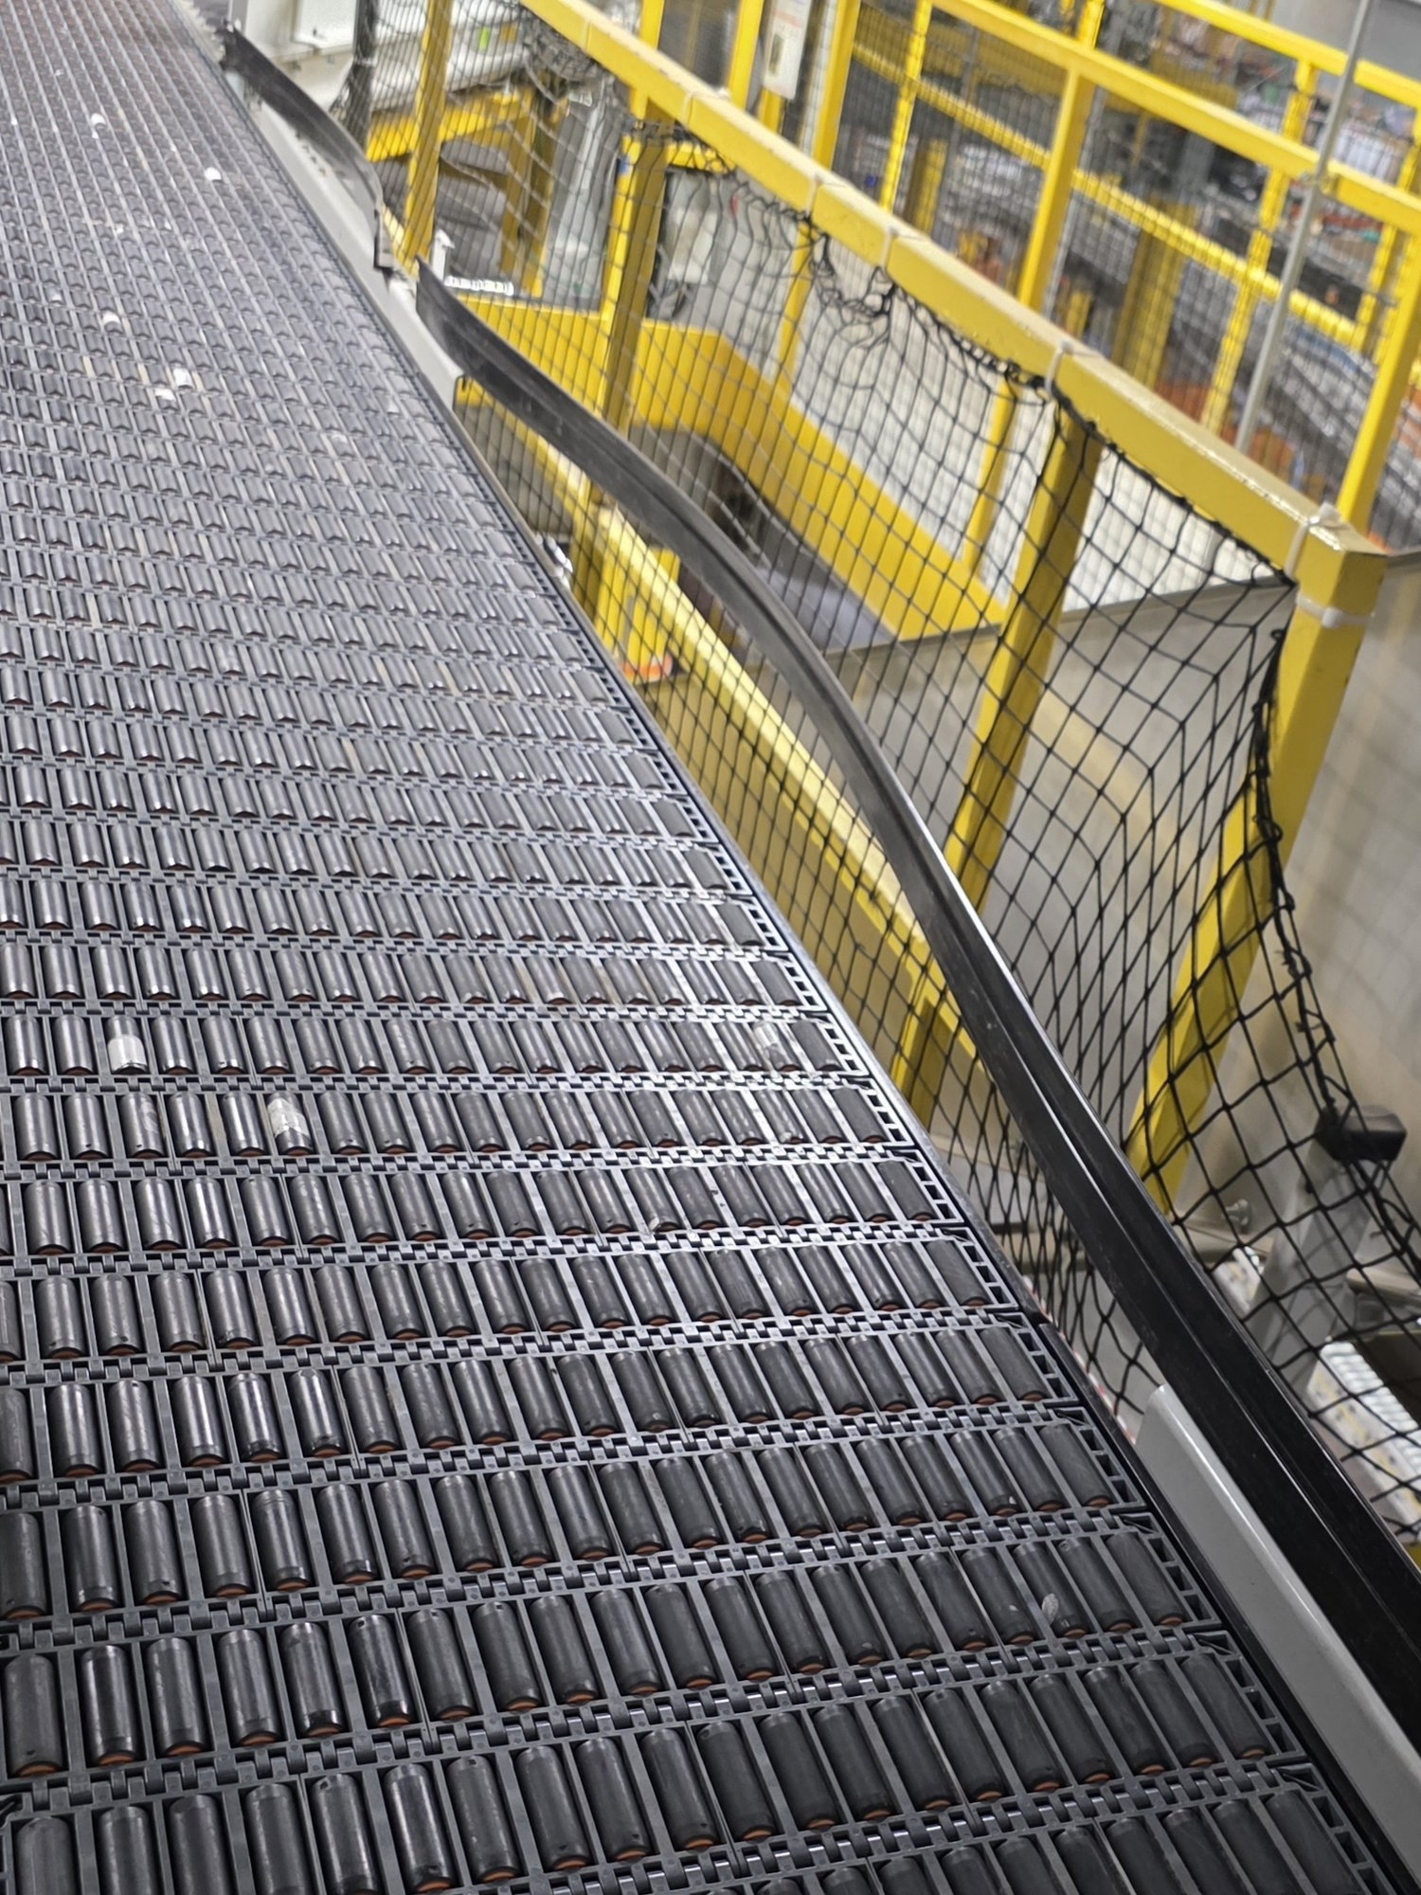
Figure 3.1: Example of a different guard rail section — not the section addressed by this project
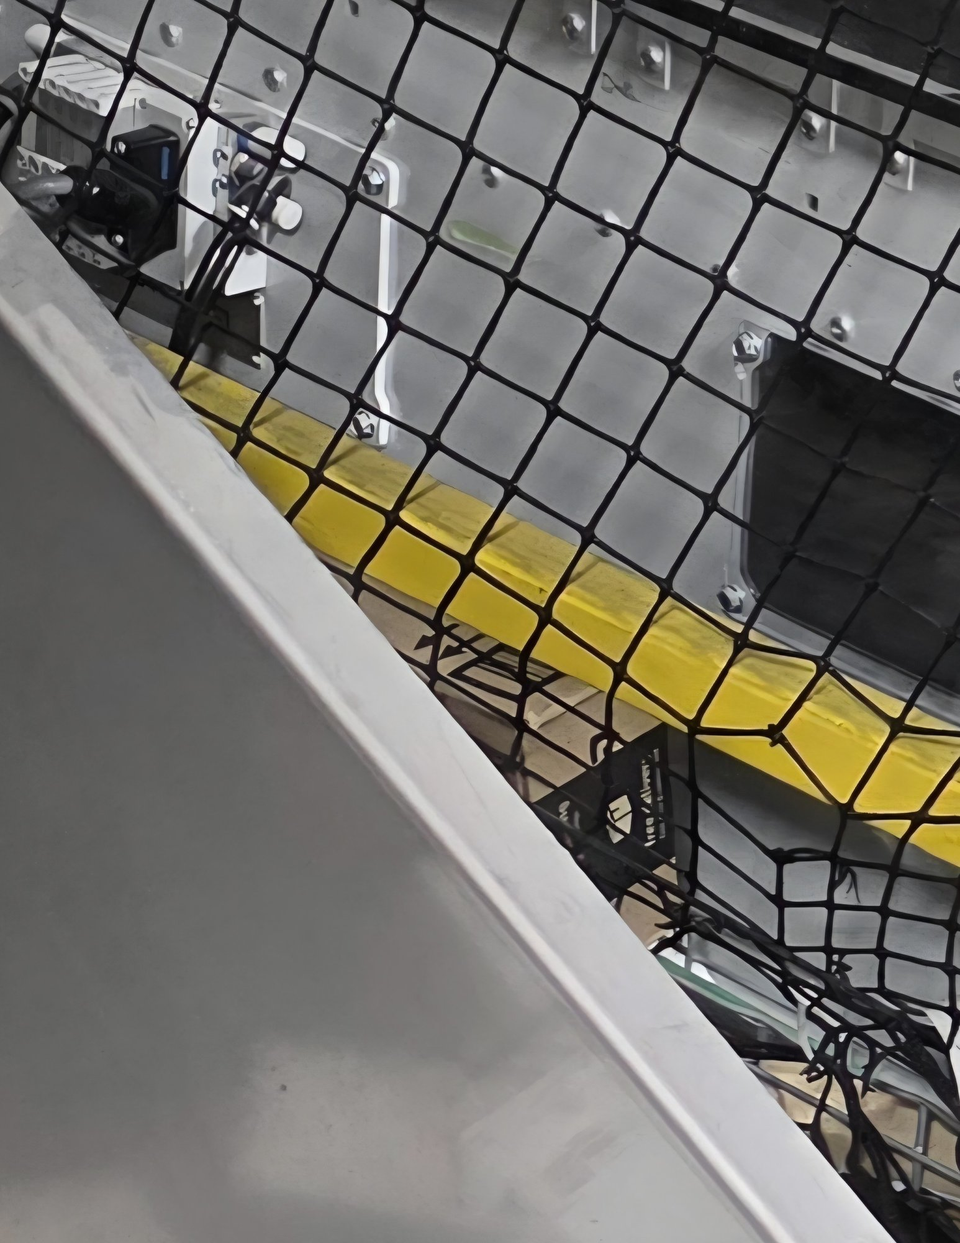

IV. Measurements and Data Collection

4.1 Conveyor Gap Measurements
Parameter | Imperial | Metric
Total guard length needed | 125 in | 3,175 mm
Distance between brackets (end to end) | 76.5 in | 1,943.1 mm
Bracket to conveyor vertical difference | 0.25 in | 6.35 mm
Parameter | Imperial | Metric
Slot length | 1.97 in | 50 mm
Slot width | 0.376 in | 9.54 mm
Distance between slots (same bracket) | 1.02 in | 25.9 mm
Distance from bracket end to first slot | 1.0 in | 25.4 mm
Bracket width | 1.08 in | 27.43 mm
Bracket thickness | 0.186 in | 4.72 mm

4.3 Clearance Measurements
Parameter | Imperial | Metric
Bracket clearance from machine | 1.5 in | 38.1 mm
Bracket center slot to belt | 2.25 in | 57.15 mm
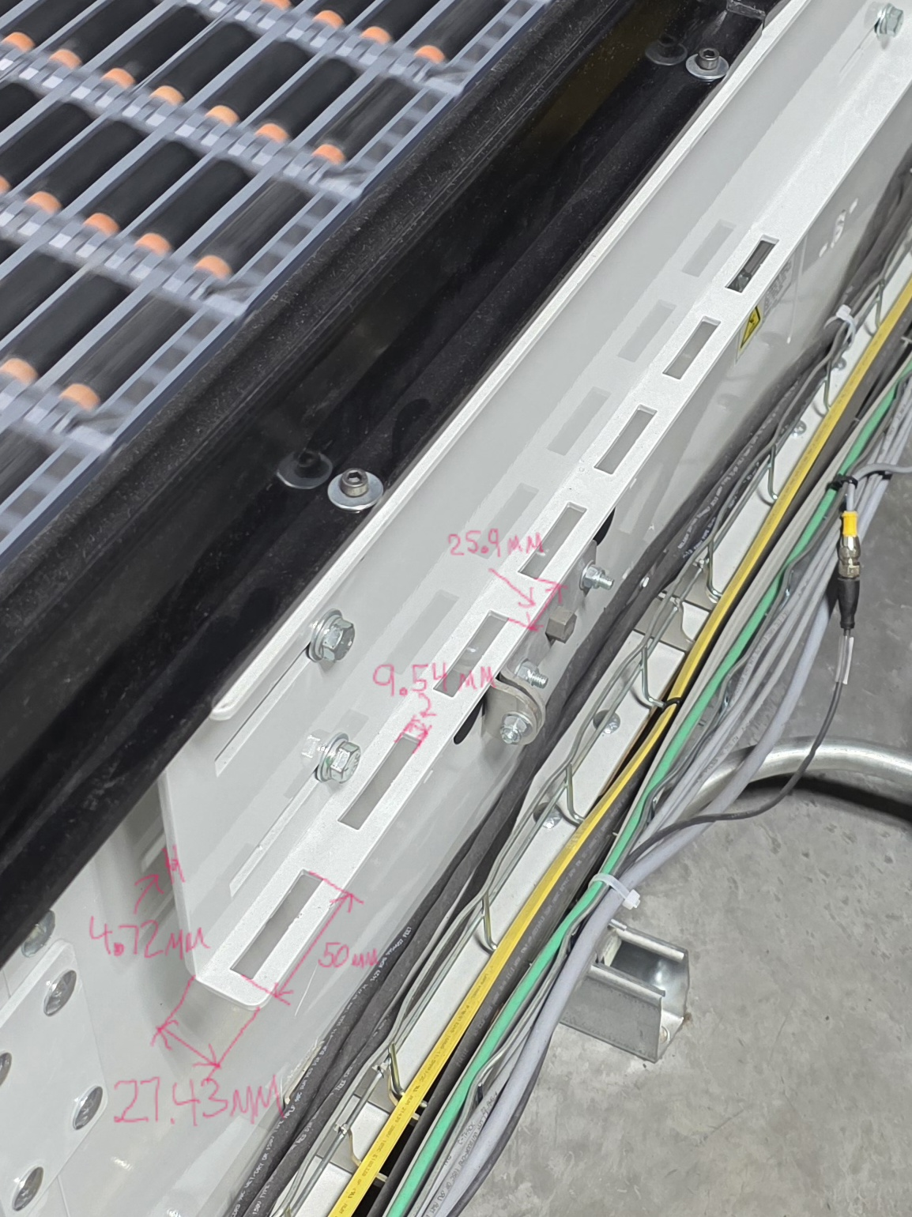
Figure 4.1: Existing L-bracket with annotated measurements (slot spacing 25.9mm, slot width 9.54mm, bracket width 27.43mm, thickness 4.72mm, slot length 50mm)
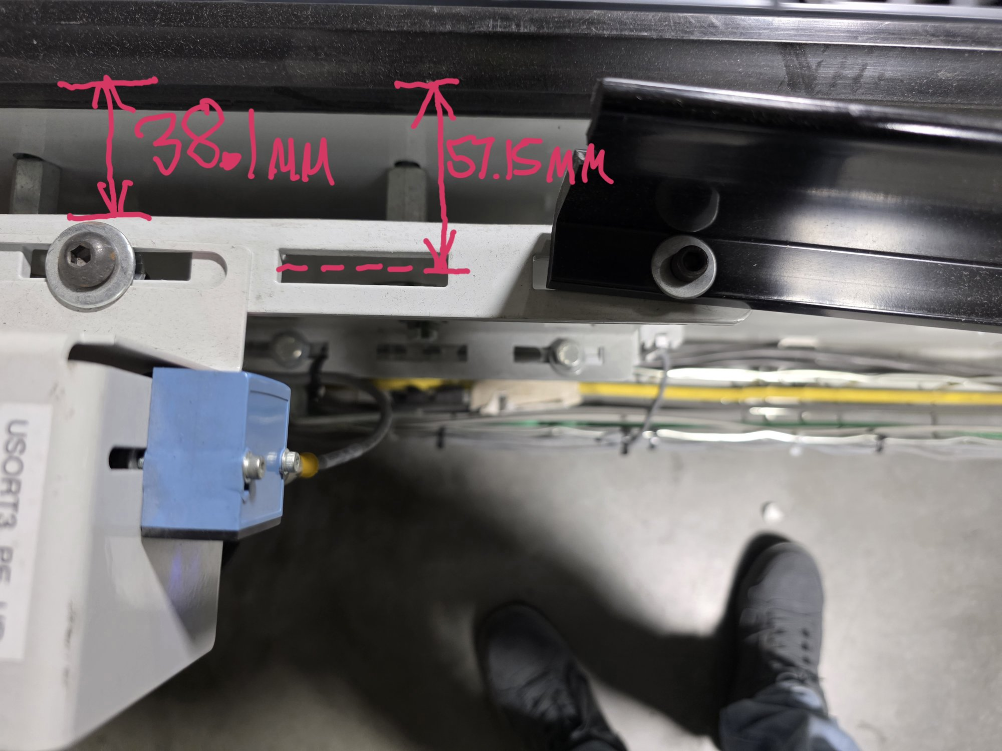
Figure 4.2: Bracket clearance measurements (38.1mm from machine, 57.15mm from center slot to belt edge)

V. Design Requirements and Constraints
Any proposed guard rail system must maintain primary function of preventing packages from leaving the conveyor while meeting the following requirements and constraints.

Functional Requirements
- Must prevent packages from falling or tipping off the conveyor within the 125-inch section
- Must be taller than the current design to accommodate various package sizes
- Must be easy to remove for servicing machines near the guard rail
- Must withstand repeated lateral impacts from packages without permanent deformation
- Must be tall enough to contain packages without requiring a top deflection feature
- Must only utilize mounting brackets at the ends of the gap (no mid-span supports on the conveyor)

Physical Constraints
- Distance between existing bracket slots: 76.5 inches; total guard rail length: 125 inches (configurable to other lengths for scalability)
- Bracket clearance from adjacent machine: 1.5 inches
- Must fit within existing slotted bracket mounting interface (M8 compatible)
- Must maintain minimum clearance from the belt surface to avoid contact
- Deflection under load must remain within acceptable limits (L/240 criterion)

Material and Sourcing Constraints
- Materials must be sourced through Amazon-approved procurement channels (Coupa)
- Budget-conscious design preferred; max material cost of $250
- 3D printed components may be utilized for non-load bearing uses
- Must use standard commercially available hardware

VI. Concept Development
Multiple guard rail concepts were developed and evaluated during the initial design phase. The following concepts were explored, ranging from simple passive systems to more complex mechanical solutions.

6.1 Elastic Band

Description
A flexible elastic band stretched between the two end brackets to provide a soft barrier against package displacement.

Advantages
- Extremely simple and low cost
- Easy to install and remove

Disadvantages
- Insufficient rigidity to prevent package falloff under lateral loads
- Elastic degradation over time would reduce effectiveness
- Does not provide a tall barrier for large packages

Feasibility Assessment
Low feasibility. While simple, the elastic band cannot provide the structural rigidity required to contain packages under normal operating loads.

6.2 Hybrid Roller/Barrier System

Description
A combination system featuring rollers along the bottom portion of the guard to reduce friction during package contact, with a rigid barrier panel on top for containment.

Advantages
- Reduces friction damage to packages
- Combines passive guidance with active containment

Disadvantages
- Increased mechanical complexity
- Higher cost due to roller components
- Maintenance requirements for roller bearings

Feasibility Assessment
Low to moderate feasibility. The added complexity and cost are not justified given the application requirements.

6.3 Roller Board

Description
A board lined with freely spinning rollers mounted between the brackets to deflect packages back toward the belt center.

Advantages
- Minimizes friction and package damage
- Self-centering effect on packages

Disadvantages
- Complex assembly with many moving parts
- Roller jamming from debris accumulation
- Difficult to clean and maintain

Feasibility Assessment
Low feasibility. Excessive complexity for the application without proportional benefit.

6.4 Retractable Belt System

Description
A retractable belt mechanism similar to crowd-control stanchions. The belt would extend between the two brackets and could feature two or three sleeves with a rigid stiffener rod to provide resistance against bending.

Advantages
- Rapid deployment and retraction for service access
- Compact when retracted

Disadvantages
- Limited structural rigidity even with stiffener rods
- Insufficient height for large package containment
- Spring mechanism fatigue over repeated cycles

Feasibility Assessment
Low to moderate feasibility. The retractable belt provides good serviceability but lacks the structural performance required.

6.5 Folding Wall Panel System

Description
A series of 12-inch by 12-inch panels attached at each end that can swivel about vertical pin joints. A solid tube behind the panels provides rigidity during operation. For service access, the tube is removed and the panels fold among each other like an accordion.

Advantages
- Provides full-height barrier when deployed
- Collapses compactly for machine access
- Maintains rigidity through backing tube

Disadvantages
- Complex hinge mechanism with multiple pivot points
- Panel alignment issues over time
- Higher manufacturing complexity

Feasibility Assessment
Moderate feasibility. Good concept for serviceability but the mechanical complexity of the pivot joints and alignment requirements add risk.

6.6 Sliding Panel on Rectangular Rail

Description
Identical panels with matching rectangular holes that slide onto a rectangular rail. All components can be 3D printed besides the rail. A slanted feature at the top helps prevent large boxes from tipping over the edge.

Advantages
- Modular design allows individual panel replacement
- No rollers or moving parts required
- Can be largely 3D printed for prototyping

Disadvantages
- Panels may rattle or shift along the rail
- Rectangular interface may not provide adequate rotational constraint
- Assembly requires sliding all panels off for removal

Feasibility Assessment
Moderate feasibility. The modular concept is promising but the sliding interface raises concerns about panel retention and noise.

6.7 ABS Thermoplastic on 2040 Aluminum Extrusion

Description
ABS thermoplastic panels shaped and attached to a 2040 (20mm x 40mm) aluminum extrusion profile. The extrusion rests on custom 3D printed brackets that mount to the existing slotted L-brackets.

Advantages
- Lightweight and cost-effective
- Standard T-slot extrusion provides flexible panel attachment
- ABS panels can be cut to size and mounted flat for a simple barrier
- 3D printed brackets allow custom fit to existing mounting

Disadvantages
- 2040 profile provides limited stiffness over the 76.5-inch span
- Deflection analysis shows ~0.5 inches at typical load (exceeds L/240 criterion)
- Would require mid-span support or doubled rail configuration

Feasibility Assessment
Moderate feasibility. The concept is sound but the 2040 profile is structurally insufficient for the unsupported span length without additional reinforcement.

6.8 ABS Thermoplastic on 4040 Aluminum Extrusion (Selected)

Description
An evolution of Concept 6.7, this design utilizes a larger 4040 (40mm x 40mm) 6063-T5 aluminum extrusion profile. The increased moment of inertia (74,200 mm4 vs 15,500 mm4) provides 4.8 times greater stiffness, eliminating the need for mid-span support. ABS panels (48 x 12 x 1/4 inch) attach to the conveyor-facing T-slot channel using M8 hardware with T-nuts, forming a flat vertical barrier. The 4040 extrusion mounts directly to the existing slotted L-brackets using M8-1.25 x 16mm button head socket cap screws from below, threading into 40-series drop-in T-nuts in the bottom-facing T-slot of the extrusion. No intermediate bracket or spacer is required.

Advantages
- 4040 profile provides sufficient stiffness without mid-span support (FOS ~5 at typical load)
- Passes L/240 deflection criterion under both typical and worst-case loading
- M8 T-slot system provides secure, adjustable panel attachment
- Symmetric profile — orientation does not affect performance
- Commercially available VEVOR extrusion at reasonable cost (~$36/rail)
- Bolts directly through existing bracket slots into T-nuts -- no intermediate bracket needed
- Entire assembly can be removed by removing two bolts

Disadvantages
- Larger profile adds weight (~5.3 lbs. per 2m rail)
- Requires precise alignment of T-nuts during installation
- Higher extrusion cost than 2040 ($145 for 4-pack vs $89.99 for 5-pack)

Safety Considerations
- No sharp edges exposed to associates or technicians
- M8 hardware provides secure fastening resistant to vibration-induced loosening
- Flat panel surface provides consistent containment without snag points

Implementation Requirements
- Small 3D printed spacers or panel aligners if needed (non-load bearing)
- M8 hardware throughout for consistent tooling
- Materials ordered through Coupa procurement

Feasibility Assessment
High feasibility. This concept provides the best balance of structural performance, serviceability, cost-effectiveness, and implementation simplicity. Selected for development and installation.

6.9 Decision Matrix

Criteria and Weighting
Concepts were evaluated against the following weighted criteria based on project requirements:
- Structural Performance (rigidity, deflection, FOS) — High weight
- Serviceability (ease of removal for machine access) — High weight
- Implementation Simplicity (minimal modification to existing hardware) — Medium weight
- Cost — Medium weight
- Durability and Maintenance — Medium weight
- Safety — High weight

Scoring Methodology
Each concept was scored on a scale of 1 to 5 for each criterion, where 5 represents the best performance. Weighted scores were summed to produce a total score for each concept.

Scoring Scale:
- 5 = Excellent — Fully meets or exceeds requirements
- 4 = Good — Meets requirements with minor limitations
- 3 = Adequate — Acceptable but with notable trade-offs
- 2 = Poor — Significant deficiencies
- 1 = Unacceptable — Does not meet minimum requirements

Weighting:
- High weight (x3): Structural Performance, Serviceability, Safety
- Medium weight (x2): Implementation Simplicity, Cost, Durability

Criteria (Weight) | 6.1 | 6.2 | 6.3 | 6.4 | 6.5 | 6.6 | 6.7 | 6.8
 | Elastic | Hybrid | Roller | Belt | Folding | Sliding | 2040 | 4040
Structural Performance (x3) | 1 | 3 | 2 | 2 | 3 | 3 | 3 | 5
Serviceability (x3) | 5 | 2 | 2 | 4 | 4 | 2 | 4 | 5
Safety (x3) | 2 | 3 | 3 | 3 | 3 | 3 | 4 | 5
Implementation Simplicity (x2) | 5 | 2 | 2 | 3 | 2 | 3 | 4 | 4
Cost (x2) | 5 | 2 | 2 | 3 | 3 | 4 | 4 | 4
Durability (x2) | 1 | 3 | 2 | 2 | 3 | 3 | 4 | 5
WEIGHTED TOTAL | 46 | 38 | 33 | 43 | 46 | 44 | 57 | 71

Ranking:
- 1st: Concept 6.8 — ABS on 4040 Extrusion (71 pts)
- 2nd: Concept 6.7 — ABS on 2040 Extrusion (57 pts)
- 3rd: Concept 6.1 — Elastic Band / Concept 6.5 — Folding Wall (46 pts)
- 4th: Concept 6.6 — Sliding Panel (44 pts)
- 5th: Concept 6.4 — Retractable Belt (43 pts)
- 6th: Concept 6.2 — Hybrid Roller/Barrier (38 pts)
- 7th: Concept 6.3 — Roller Board (33 pts)

Results and Selection
Based on the decision matrix evaluation, physical measurements, and engineering calculations, the selected concept for further development is the ABS Thermoplastic on 4040 Aluminum Extrusion (Concept 6.8).
This concept scored highest due to its combination of structural adequacy (FOS = 5.0 worst-case), excellent serviceability (two bolts per bracket for full removal), implementation simplicity (uses existing mounting slots without modification), and reasonable cost (~$198 total materials).

VII. Engineering Calculations
Structural analysis was performed to evaluate candidate extrusion profiles and determine adequacy for the unsupported 76.5-inch span. Deflection and stress calculations follow standard beam theory for a simply-supported beam with a concentrated midpoint load.

7.1 2040 Profile Deflection Analysis
Material: 6063-T5 Aluminum (E = 68.9 GPa, σ_{yield} = 145 MPa)
Moment of Inertia (strong axis): I = 15,500 mm⁴
Span: 1,943.1 mm (76.5 in)

Parameter | Design (48 N / 11 lbf) | Worst-Case (297 N / 67 lbf)
Deflection (simply supported) | 6.87 mm (0.27 in) | 42.51 mm (1.67 in)
Factor of Safety | 4.8 | 0.8
L/240 Limit (8.1 mm) | PASSES ✔ | EXCEEDS ✖

Conclusion: The 2040 profile is structurally insufficient for the 76.5-inch span without mid-span support or doubled rail configuration.

7.2 4040 Profile Deflection Analysis
Material: 6063-T5 Aluminum (E = 68.9 GPa, σ_{yield} = 145 MPa)
Moment of Inertia: I = 74,200 mm⁴ (4.8× stiffer than 2040 strong axis)
Span: 1,943.1 mm (76.5 in)
Weight: ~5.3 lbs. per 2m rail

Parameter | Design (48 N / 11 lbf) | Worst-Case (297 N / 67 lbf)
Deflection (simply supported) | 1.44 mm (0.056 in) | 8.88 mm (0.35 in)
Factor of Safety | 23.1 | 3.7
L/240 Limit (8.1 mm) | PASSES ✔ | EXCEEDS ✖

Conclusion: The 4040 profile provides adequate stiffness and strength for the unsupported span under all anticipated loading conditions. No mid-span support is required.

7.3 Bolt Length and Stack-Up Analysis
The guard rail assembly uses two independent bolt connections: one mounting the 4040 extrusion to the existing L-brackets, and one attaching the ABS panels to the extrusion. Each has a separate stack-up.

Mounting Stack-Up (extrusion to existing bracket):
- M8 bolt passes up through the existing L-bracket slot into a T-nut seated in the bottom channel of the 4040 extrusion.
- Bracket thickness: 4.72 mm
- Hardware: M8-1.25 × 25mm button head socket cap screws with 40-series drop-in T-nuts

Panel Stack-Up (ABS panel to extrusion):
- M8 bolt passes through the ABS panel, through a spacer, and into a T-nut in the side-facing T-slot channel of the extrusion.
- ABS panel thickness: 6.35 mm (1/4 inch)
- Hardware: M8-1.25 × 35mm button head socket cap screws with 40-series spring ball T-nuts

7.4 Factor of Safety Summary
Load Case | 2040 Profile | 4040 Profile
Design (48 N / 11 lbf) | FOS = 4.8 | FOS = 23.1
Worst-Case (297 N / 67 lbf) | FOS = 0.8 | FOS = 3.7
Target FOS | ≥ 2.0 | ≥ 2.0

The 4040 profile exceeds the minimum target factor of safety of 2.0 under all measured loading conditions (FOS = 23.1 at design load, FOS = 3.7 at worst-case), confirming its suitability for the application. Loading values were derived from 29 on-site package weight measurements and timed belt speed observations.

7.5 Vibration Torque Analysis
A torque analysis was performed to determine the minimum tightening torque required to prevent vibration-induced loosening of the M8 mounting bolts. The analysis follows the Junker loosening criterion, which relates bolt preload to the transverse cyclic forces experienced during conveyor operation.

Formula:
T = K × d × (SF × F_{transverse}) / μ_{joint}
Where:
T = Required tightening torque (N·m)
K = Nut factor: 0.20 (dry stainless steel)
d = Nominal bolt diameter: 0.008 m (M8)
SF = Safety factor: 2.0 (standard for vibration applications)
F_{transverse} = Lateral force per bolt: 148.5 N (worst-case: 297 N ÷ 2 bolts per bracket)
μ_{joint} = Friction coefficient of clamped surfaces: 0.12 (aluminum extrusion / steel T-nut interface)
Calculation:
T = 0.20 × 0.008 × (2.0 × 148.5) / 0.12 = 3.96 N·m (35 in·lbf)
Verification: Maximum allowable torque (75% of bolt yield) for M8 304 stainless steel (A2-70, σ_{yield} = 450 MPa, A_{tensile} = 36.6 mm²) is 19.8 N·m. The required 4.0 N·m represents only 20% of the bolt capacity, confirming no risk of over-torquing.
Conclusion: A minimum torque of 4.0 N*m is sufficient to prevent vibration-induced loosening through friction alone. Installation specification: hand-tight plus one-quarter turn (approximately 5-10 N*m).

VIII. Safety and Risk Assessment
A safety and risk assessment was conducted to identify potential hazards associated with the design, fabrication, installation, and operation of the guard rail system. Risks were evaluated using a severity-likelihood matrix and mitigation strategies were developed for each identified hazard.

# | Hazard | Severity | Likelihood | Mitigation
1 | Sharp edges on cut ABS panels | Medium | Medium | Deburr and sand all cut edges; heat-form edges to round profile
2 | Pinch points during bracket installation | Medium | Low | Use proper PPE (gloves); two-person install if needed
3 | Bracket failure under impact load | High | Low | Design to FOS >= 5.0; secure M8 fastening with adequate torque prevents loosening
4 | Guard rail dislodging during operation | High | Low | Secure bolt fastening; periodic inspection schedule
5 | Extrusion rail falling during removal | Medium | Low | Two-person removal procedure; rail weighs approx. 5.3 lbs (manageable)
6 | Hardware dropping into conveyor mechanism | High | Low | Captive hardware design; install/remove with belt stopped per LOTO
7 | Vibration-induced fastener loosening | Medium | Medium | Adequate torque on all bracket bolts; T-nut spring retention

Design Safety Features
The guard rail system incorporates several inherent safety features:
No sharp edges exposed to associates -- all ABS edges deburred and sanded
Flat vertical panels contain packages without redirecting them unpredictably
Secure bolt fastening on all bracket connections prevents vibration-induced loosening
Bolt head profile sits below panel surface -- no snag hazards
Entire assembly removable without cutting or destructive disassembly
M8 hardware throughout allows single-tool maintenance

Installation Safety Protocol
Installation and removal of the guard rail assembly shall be performed in accordance with site Lockout/Tagout (LOTO) procedures. The conveyor belt must be stopped and locked out prior to any work on the guard rail system. A minimum of one technician is required for installation; two-person installation is recommended for initial setup to manage rail alignment for longer assemblies.
Criteria (Weight) | 6.1 | 6.2 | 6.3 | 6.4 | 6.5 | 6.6 | 6.7 | 6.8
 | Elastic | Hybrid | Roller | Belt | Folding | Sliding | 2040 | 4040
Structural Performance (x3) | 1 | 3 | 2 | 2 | 3 | 3 | 3 | 5
Serviceability (x3) | 5 | 2 | 2 | 4 | 4 | 2 | 4 | 5
Safety (x3) | 2 | 3 | 3 | 3 | 3 | 3 | 4 | 5
Implementation Simplicity (x2) | 5 | 2 | 2 | 3 | 2 | 3 | 4 | 4
Cost (x2) | 5 | 2 | 2 | 3 | 3 | 4 | 4 | 4
Durability (x2) | 1 | 3 | 2 | 2 | 3 | 3 | 4 | 5
WEIGHTED TOTAL | 46 | 38 | 33 | 43 | 46 | 44 | 57 | 71

IX. Fabrication and Installation

9.1 Project Plan
The guard rail system was assembled and installed on SLAM Line 501. The system covers a 125-inch section using VEVOR 4040 aluminum extrusion sections (78 inches + 47 inches), connected end-to-end with a 4040 linear connector, with ABS panel barriers attached.
The project was completed in the following phases:
- Phase 1: Order materials through Coupa
- Phase 2: Test-fit 4040 extrusion on existing brackets
- Phase 3: Cut and form ABS panels
- Phase 4: Full assembly and installation
- Phase 5: Functional testing and evaluation
- Phase 6: Document results and finalize report

9.2 Direct Mounting Method
The 4040 aluminum extrusion mounts directly to the existing steel L-brackets without any intermediate bracket or spacer. M8-1.25 x 25mm button head socket cap screws pass upward from below through the existing slotted mounting holes in the L-bracket and thread into 40-series drop-in T-nuts seated in the bottom-facing T-slot of the 4040 extrusion. This eliminates the need for a custom bracket entirely, reducing part count and simplifying installation.

Mounting Configuration:
- Bolt: M8-1.25 x 15mm button head socket cap screw (from below, through the bracket and into the t-nut)
- T-nut: 40-series drop-in M8 T-nut in bottom channel of 4040
- Alignment: T-nut centered in slot, bolt passes through 9.54mm wide bracket slot
- Two mounting points per bracket (using both existing slots, 25.9mm apart); one M8 washer per side under bolt head

Advantages of Direct Mounting:
- No 3D printed structural components required
- Fewer parts -- simpler assembly and fewer failure modes
- Load path goes directly from extrusion through M8 bolts into steel bracket

9.3 Panel Layout and Cutting Plan
Three ABS panels (48 x 12 x 1/4 inch sheets, vacuum forming grade) are used for the barrier. Panel layout was determined by the SLAM Guard Rail Configuration Tool, which calculated bolt positions, spacer thickness, and cut lengths for the 125-inch total coverage.
- Panel 1: Cut to 29.0 inches (736.6 mm), 4 bolts, 9.0-inch bolt spacing, positioned at start of rail
- Panel 2: Full sheet 48.0 inches (1219.2 mm), 6 bolts, 9.2-inch bolt spacing
- Panel 3: Full sheet 48.0 inches (1219.2 mm), 6 bolts, 9.2-inch bolt spacing
- Spacer: 3D printed, 6.1mm thick (9.8mm OD, 9mm ID for M8 clearance). Note: 6.1mm was used due to a configuration input error; the calculated spacer should have been 9mm, but the 6.1mm spacer functions correctly.
- Extrusion: Two sections (2000mm / 78.74" + 1175mm / 46.26") joined with 2 x 180mm linear connectors (bottom + back T-slots)
- Total coverage: 125.0 inches (3175mm). Panel order from left: 29" + 48" + 48" = 125". 16 bolts total across all panels.

9.4 Hardware Selection and BOM
All hardware is M8 throughout for consistent tooling. The following bill of materials has been prepared for Coupa ordering:

Item | Qty | Est. Cost
ABS Panel (48x12x1/4", 3 sheets, 125" used) | 3 | $119.79
4040 Extrusion (2 pcs, 2000mm + 1175mm) | 2 | $47.63
180mm Straight Linear Connector | 2 | $8.00
M6 Set Screw (included w/ connector) | 8 | $0.00
M8x25mm Button Head Bolt, SS | 16 | $9.12
M8 Spring Ball T-nut (4040 slot) | 20 | $9.40
M8 Washer (bracket mounting) | 2 | ~$0.50
3D Printed Spacer (6.1mm, filament cost) | 16 | $4.00
TOTAL |  | ~$198

9.5 Linear Connector Installation

Two 180mm aluminum straight-line connectors (4040 series, 8mm T-slot profile) were installed at the joint between the two extrusion sections. One connector was placed in the top T-slot and one in the back-facing T-slot, providing rigidity in both vertical and lateral directions. Each connector is secured with four M6 set screws (included with the connector) that lock into the T-slot walls. The connectors ensure the two extrusion pieces act as a single rigid rail across the 125-inch span, preventing any deflection or play at the joint.

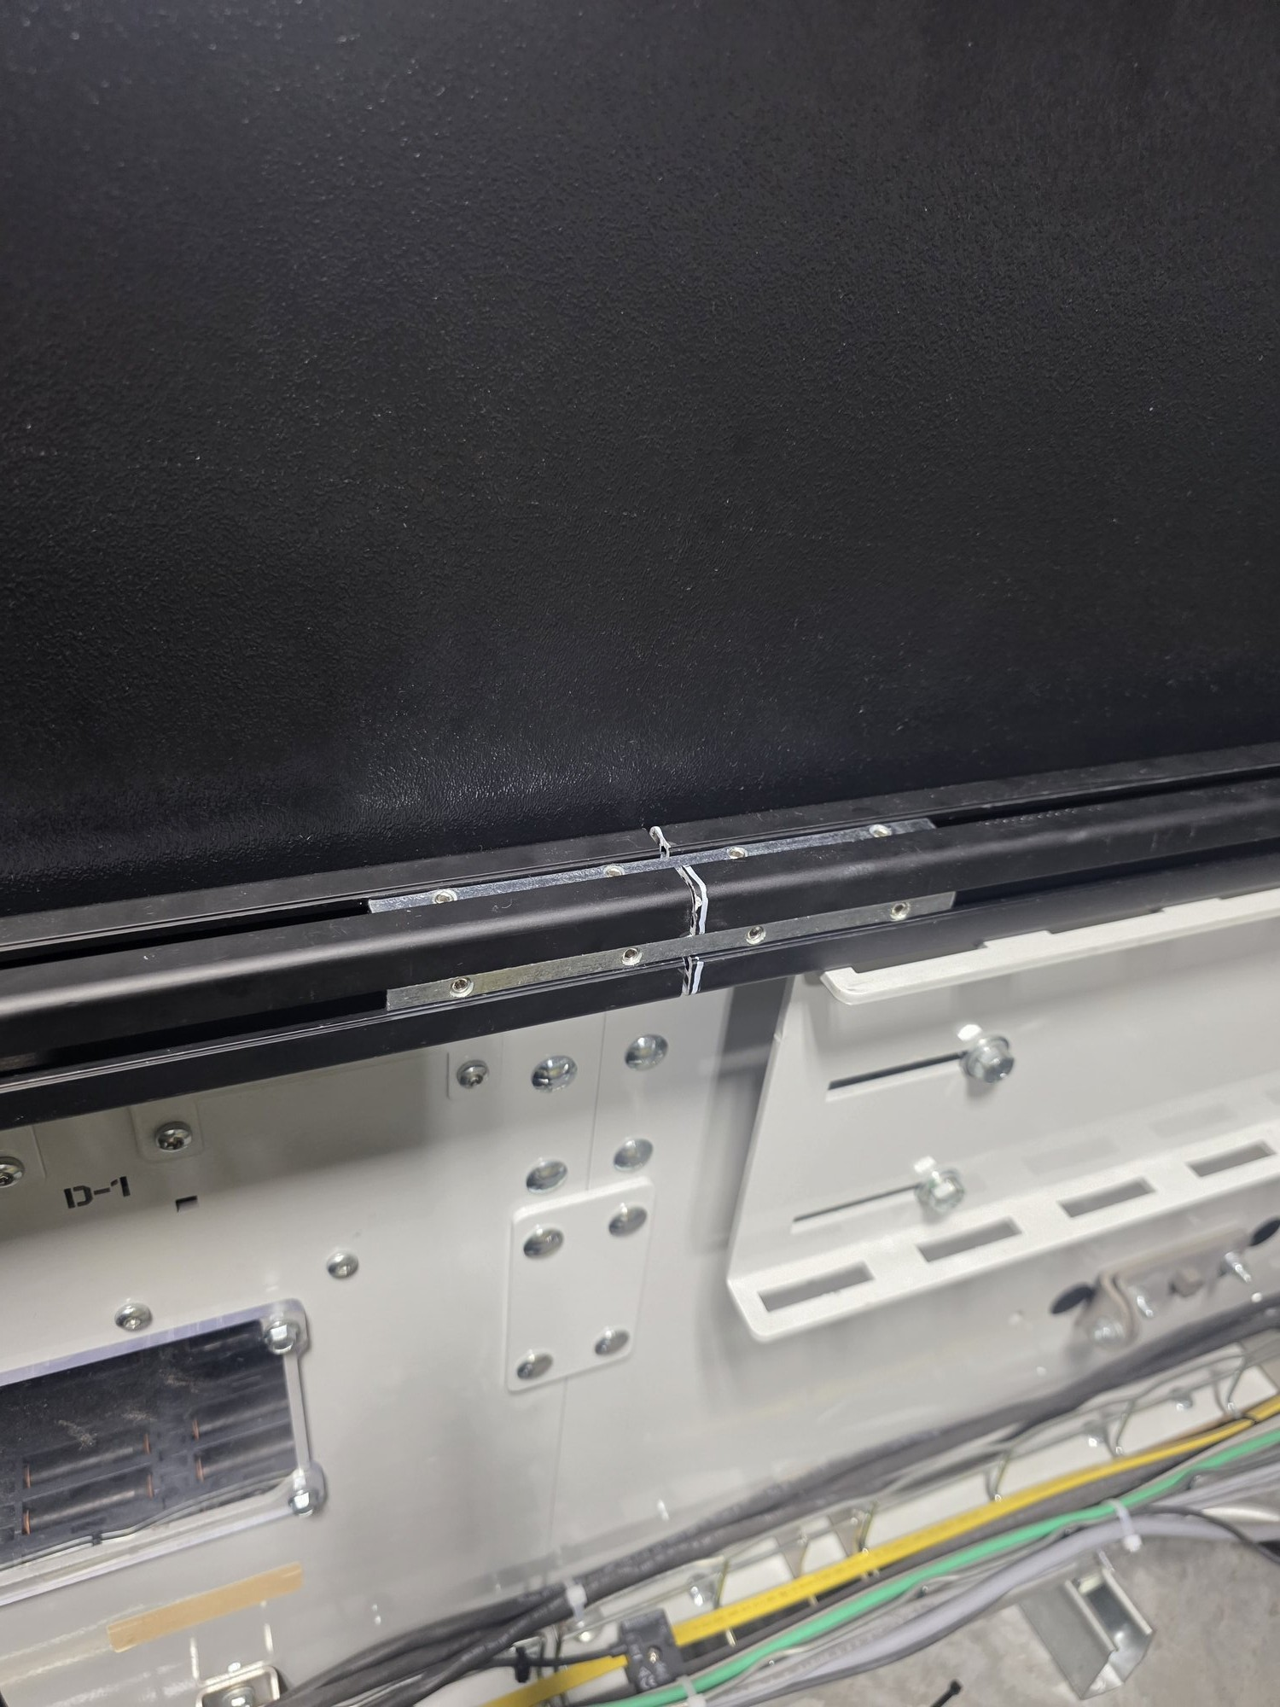
Figure 10.4: Linear connectors installed at the rail joint, joining two 4040 extrusion sections end-to-end

9.6 Panel Aligner Bracket

The Panel Aligner Bracket is a custom 3D-printed component designed to keep ABS panels aligned and co-planar where two panels meet. Without it, slight misalignment at panel joints can create small protrusions or steps that could catch packages. The bracket sits at the top of the panels without overhanging, spanning between adjacent panel edges.

The bracket features two rectangular T-nut retention slots. M8 spring ball T-nuts — the same type used throughout the rail assembly — are repurposed as captive nuts by dropping them into the bracket's rectangular slots, where the slot geometry prevents rotation and allows tightening without introducing any new hardware types.

Installation Procedure:
1. Download the STL file from the Configuration Tool and 3D print the bracket.
2. Using the built-in center-marking features on the printed part, mark hole centers on the ABS panel with a paint marker at the desired panel joint location.
3. Remove the center-marking pins by pressing them through the 9mm clearance holes — they are designed to break away cleanly with minimal force.
4. Drill counterbores at each marked location, then drill the 9mm through-holes at the center of each counterbore.
5. Insert short M8 bolts through the panel holes from the conveyor-facing side (bolt heads facing toward the conveyor).
6. Place the bracket on the back side of the panels with the rectangular retention slots facing away from the panel surface.
7. Drop M8 spring ball T-nuts into the rectangular slots with the spring ball facing away from the panel. The slot geometry prevents the T-nut from rotating, allowing it to function as a captive nut.
8. Thread the bolts into the T-nuts and tighten by hand until both panel edges are drawn flush and co-planar against the bracket face. Thread-locking compound may be applied if vibration-induced loosening is observed during operation.

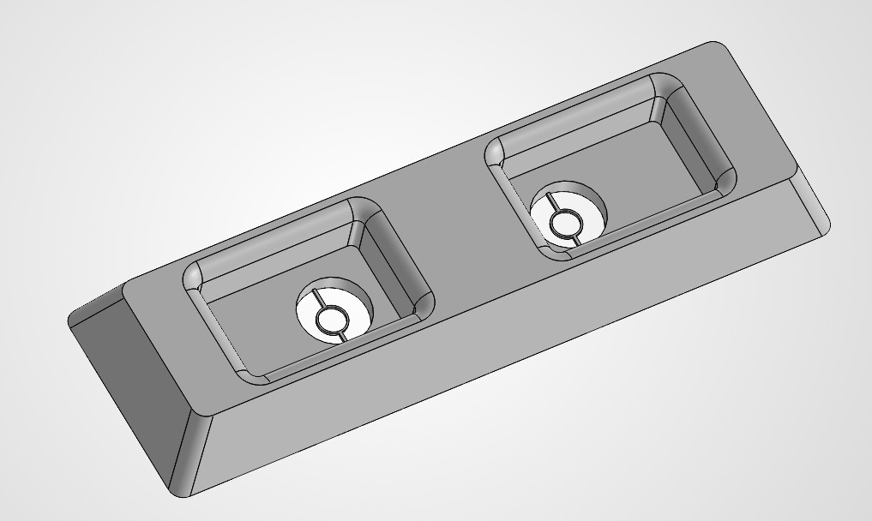
Figure 10.5: Panel Aligner Bracket — Isometric View (SolidWorks CAD model)

A complete engineering drawing with dimensions and tolerances is provided in the appendices (see: Panel Aligner Bracket Drawing.pdf).

X. Configuration Tool
A custom SLAM Guard Rail Configuration Tool was developed to automate the design, layout, and fabrication planning for guard rail assemblies of any length. The tool takes user-specified parameters (total coverage length, panel height, bolt spacing preferences, and gap measurements) and outputs a complete fabrication package including panel layout, bolt positions, spacer dimensions, drill/cut guides, and a cost estimate.

Key Features and Capabilities
- Interactive panel diagram with side, top, and a cross-section view showing bolt positions, panel seams, and other key geometry
- Automatic calculation of optimal bolt spacing and panel cut lengths for any total coverage length
- Per-panel drill guide with exact hole positions measured from panel edges
- Automatic 3D printed spacer calculation based on user input measurements, with STL file generation for immediate printing
- One-click STL download for the panel aligner bracket
- Complete bill of materials with itemized cost estimate
- Export to printable PDF for shop/floor use during fabrication
- Export to Excel spreadsheet for procurement and documentation
- Validation checks: structural FOS calculation, minimum bolt spacing warnings, panel flex warnings

Tool Outputs
For the 125-inch guard rail installation on SLAM Line 501, the configuration tool generated the following outputs which were used directly for fabrication and assembly:
- Panel layout: 3 panels (29.0" + 48.0" + 48.0"), 16 bolts total, optimized bolt spacing
- Extrusion cut list: 2 sections (2000mm + 1175mm) joined with 180mm linear connectors
- Spacer specification: 6.1mm thick, 9.8mm OD, 9mm ID (M8 clearance), 16 required
- Drill guide: 9mm through-hole + 15mm counterbore x 3mm deep for each bolt position
- Estimated minimum FOS: 22.1x (limited by panel flex)
- Total estimated cost: $197.94

Screenshots

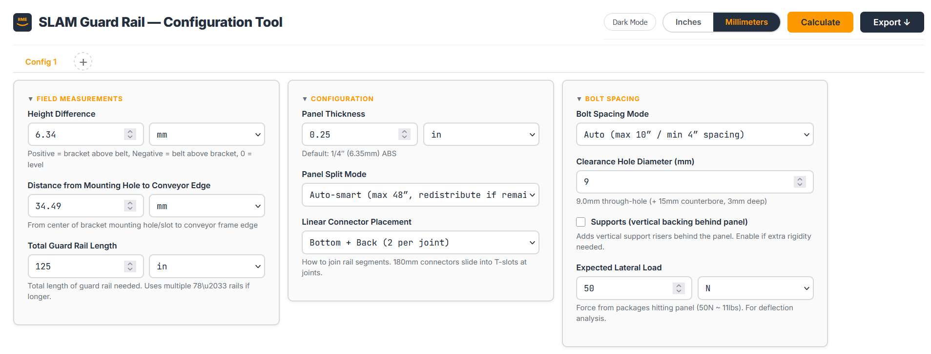
Figure 11.1: Configuration Tool — Input Fields and Top Banner

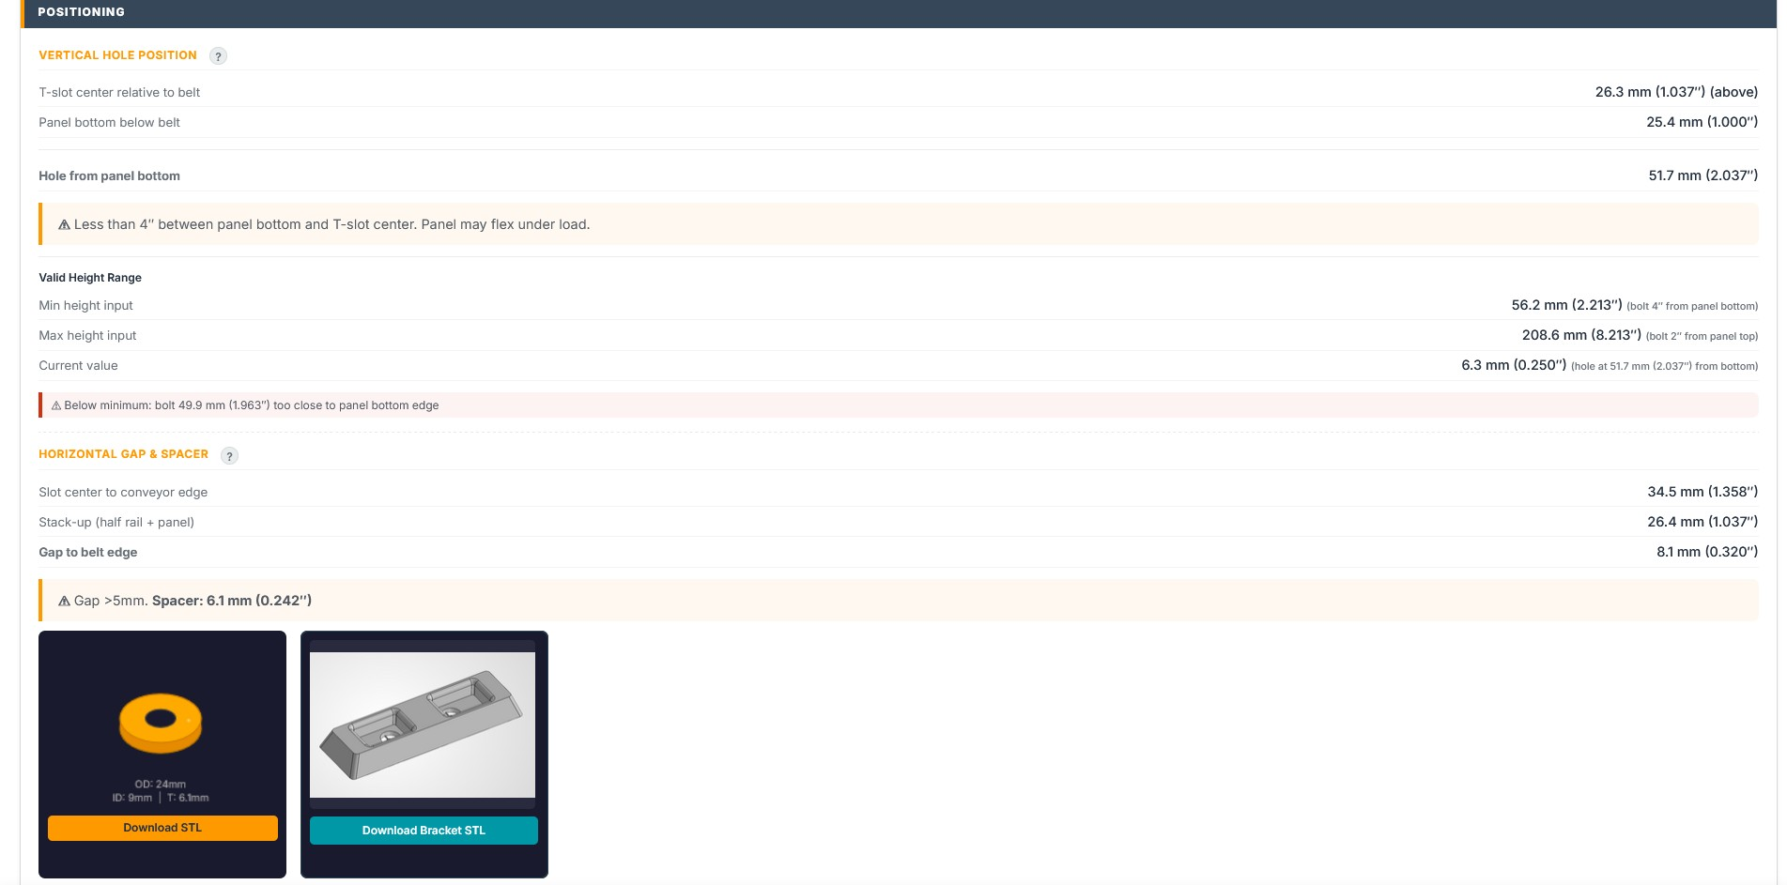
Figure 11.2: Measurements Section — Positioning (Vertical Hole Position, Horizontal Gap & Spacer, STL Downloads)

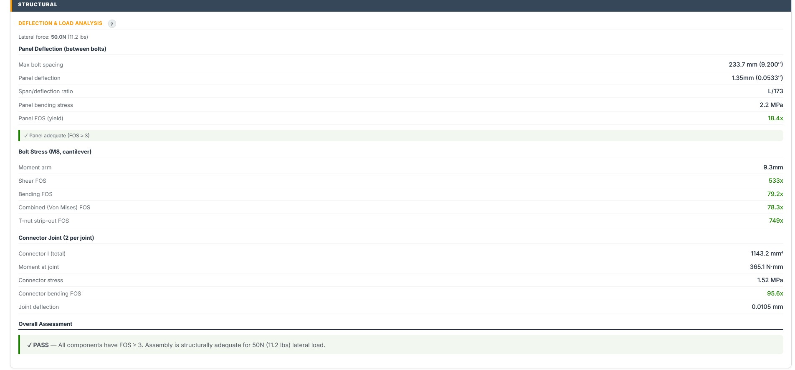
Figure 11.3: Measurements Section — Structural Analysis (Deflection, FOS, Connector Joint)

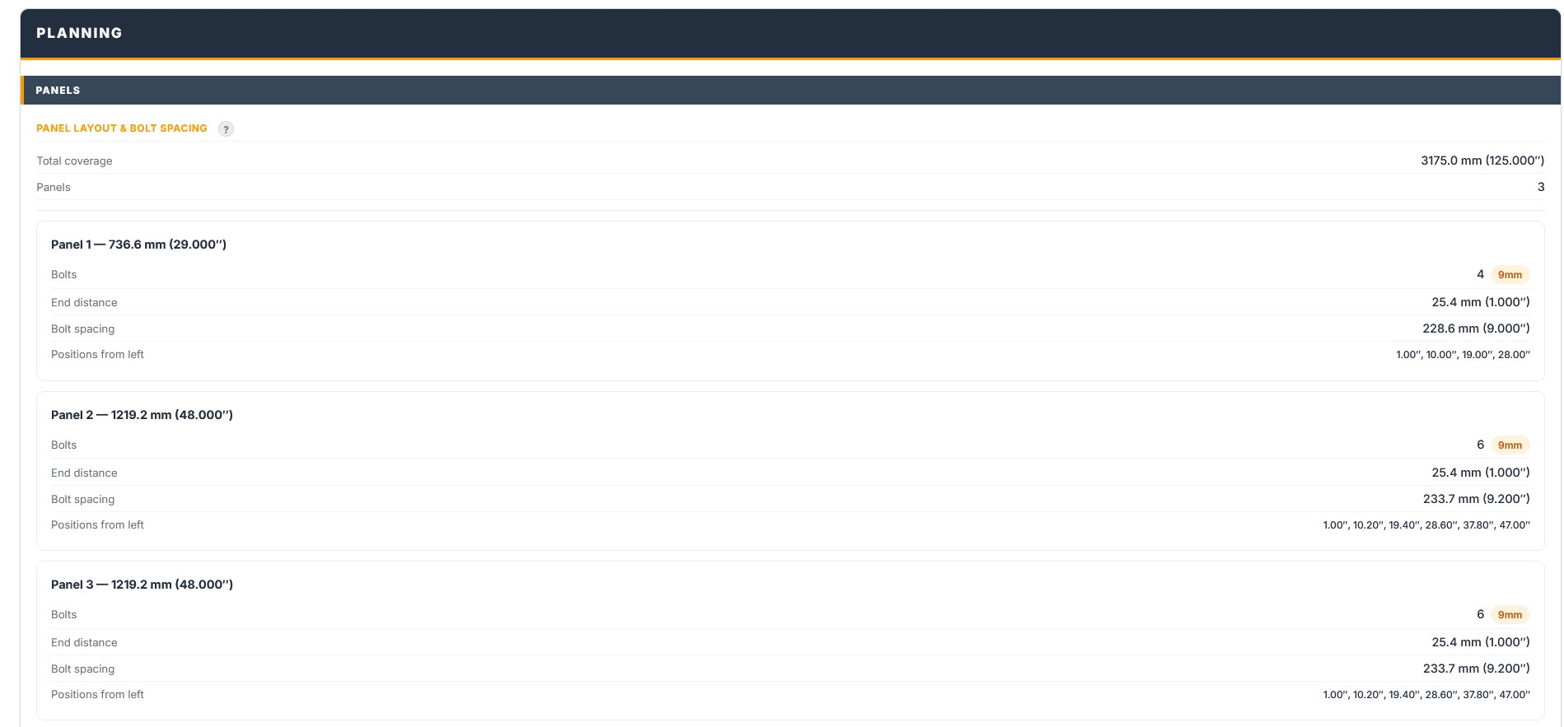
Figure 11.4: Planning Section — Panel Layout & Bolt Spacing

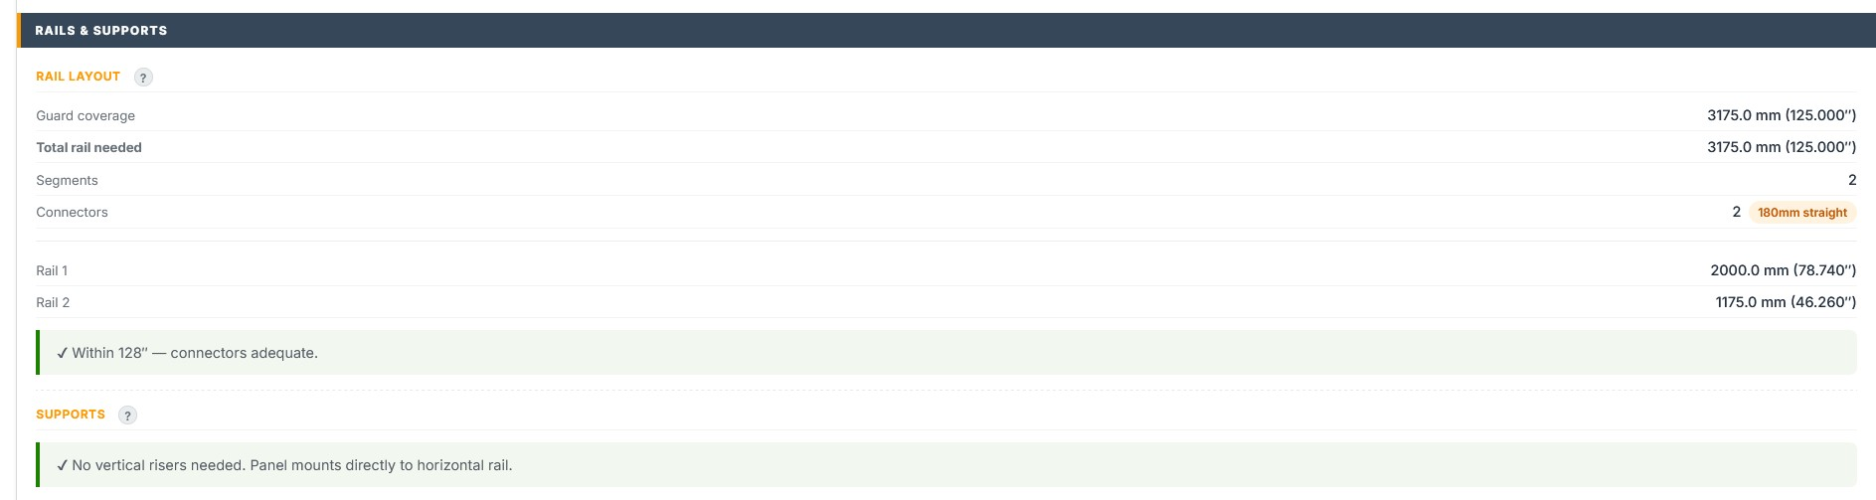
Figure 11.5: Planning Section — Rail Layout & Supports

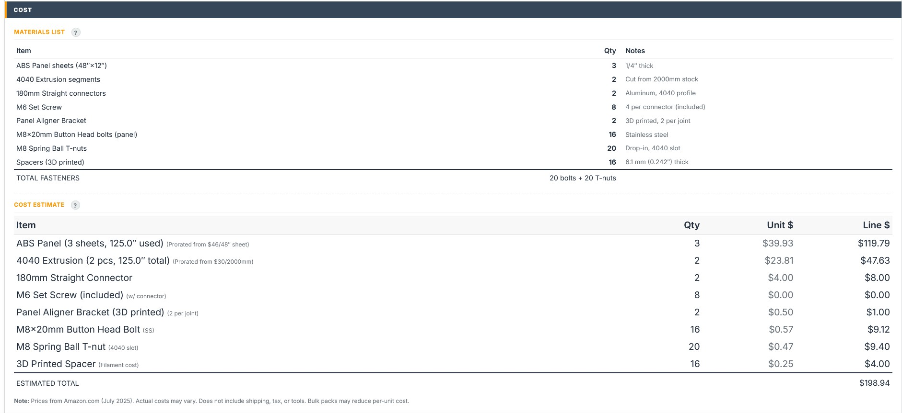
Figure 11.6: Planning Section — Materials List & Cost Estimate

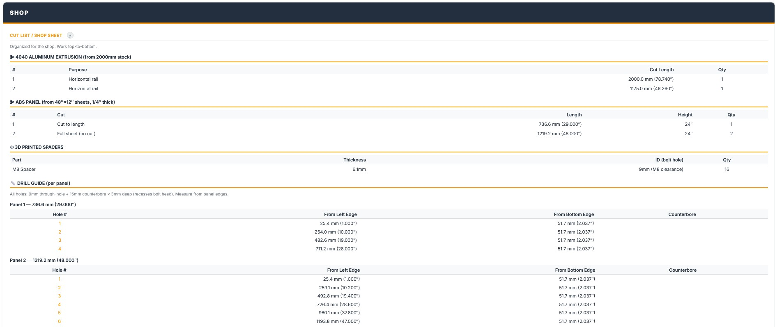
Figure 11.7: Shop Section — Cut List, Spacer Specs, and Drill Guide

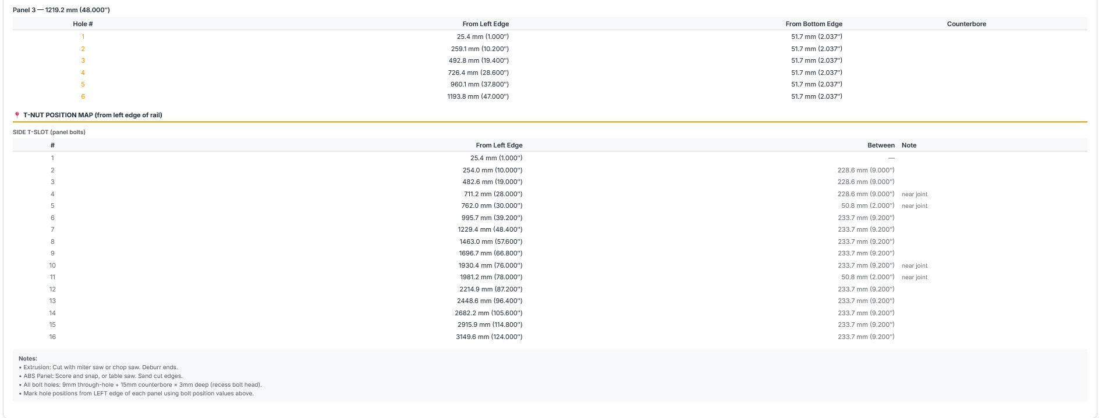
Figure 11.8: Shop Section — T-Nut Position Map

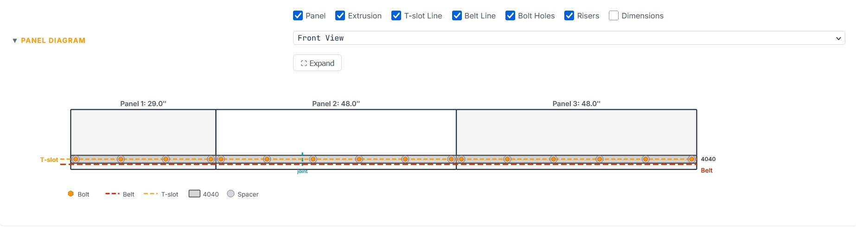
Figure 11.9: Panel Diagram — Front View (showing panels, bolts, rail joint, and extrusion)

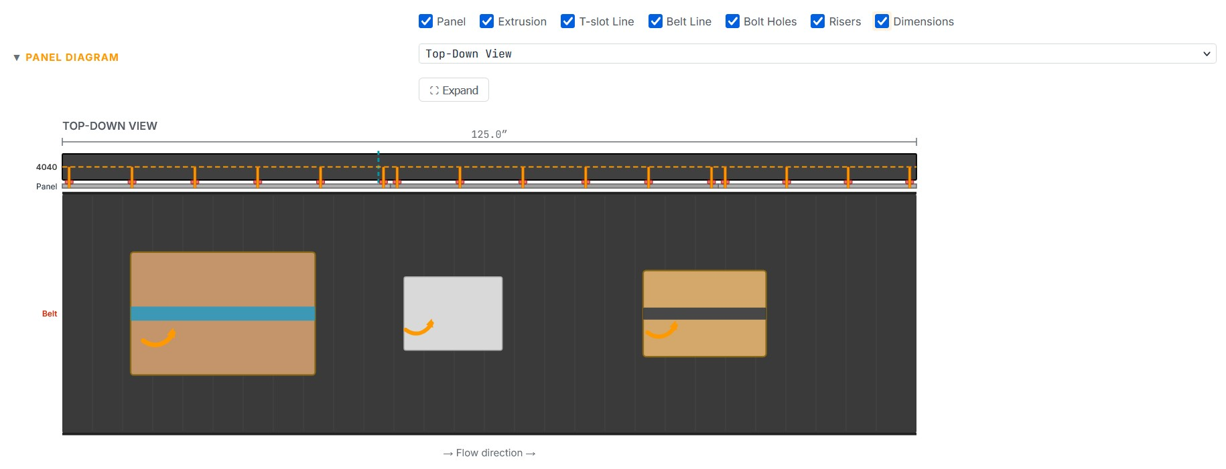
Figure 11.10: Panel Diagram — Top-Down View (horizontal, with conveyor packages)

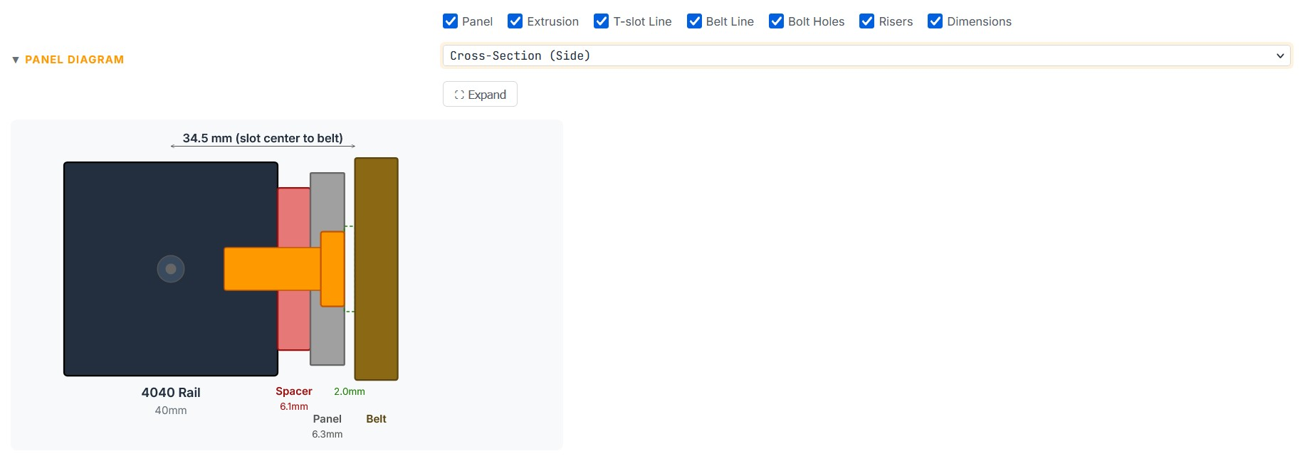
Figure 11.11: Panel Diagram — Cross-Section Side View (rail, spacer, panel, bolt, conveyor edge)

Development Method and Maintenance

The Configuration Tool was developed iteratively using Amazon Quick, an AI-powered work assistant. The tool's HTML, CSS, and JavaScript code was authored, tested, and refined through a conversational development process spanning multiple sessions. This approach enabled rapid prototyping with integrated structural engineering calculations, real-time validation logic, and interactive diagram generation — all within a single standalone HTML file requiring no external dependencies or installation.

To make future updates, bug fixes, or feature additions to the Configuration Tool, the recommended process is:

1. Open a new Amazon Quick AI chat session.
2. Upload both the HTML file and the knowledge transfer file (SLAM Config Tool — Knowledge Transfer.txt) which contains the complete technical context, architecture details, design decisions, and current state of the tool.
3. Describe the desired change, bug fix, or new feature in plain language.
4. The AI will read and modify the HTML file directly, maintaining consistency with the existing code structure and design patterns.
5. After changes are made, open the HTML file and perform a refresh in the browser to clear cached versions and verify the update.

Note: While extensive testing was performed during development — including combinatorial input sweeps across thousands of parameter combinations — the tool may still contain undiscovered bugs or edge cases. Users who encounter unexpected behavior should report the issue and use the above process to request a correction or correct themselves. The knowledge transfer file ensures continuity between development sessions regardless of which AI instance handles the update.

XI. Results and Analysis
Package drop data was collected and analyzed to quantify the impact of unguarded conveyor gaps and establish the business case for guard rail installation. Data was sourced from the #tpa4-dea-risk Slack channel where DEA associates log packages found on the floor beneath SLAM line conveyors.

11.1 Pre-Installation Baseline Data
Over a five-and-a-half-month observation period (February 15 through August 2, 2026), 189 individual package drop reports were collected from the #tpa4-dea-risk Slack channel. These reports document packages physically falling from SLAM line conveyors at nine separate locations. Data was extracted programmatically via the Slack API, scanning over 24,000 messages across the channel history.

Key baseline metrics:
Observation period: 169 days (February 15 - August 2, 2026)
Total reports: 189 across 74 reporting days
Total observed drops: 1,552 packages across 9 SLAM lines
SLAM lines monitored: 108, 107, 106, 105, 305, 304, 303, 502, 501
Average drops per shift: ~12 packages (82 reports, all 9 SLAM lines)

Critical finding: Shift coverage gap
Analysis of report timestamps revealed that 100% of the 189 reports fall between 6:00 PM and 5:00 AM, Sunday through Wednesday only. This corresponds exclusively to the Front Half Night (FHN) shift. The complete absence of data from Front Half Day, Back Half Night, and Back Half Day shifts does not indicate zero drops during those periods — it indicates non-reporting. The facility operates the same conveyor equipment across all shifts with the same unguarded gaps. A minimum 2x multiplier is required to estimate facility-wide totals, as only one of four weekly shifts reports drop data.

11.2 Statistical Analysis
The annual cost of package drops was estimated using a volume-calibrated drop rate method, combining actual package throughput from the AFT Dashboard with observed drop counts from Slack.

Estimation Method
Over the observation period (Feb 15 – Aug 2, 2026), 82 shift reports documented a total of 1,017 packages on the floor across all 9 SLAM lines. This gives an average of ~12 packages per shift. Scaling to both shifts (×2) and 355 operating days per year yields ~8,800 packages/year. At $2.50 per DEA miss: approximately $22,000/year.

At a guard rail implementation cost of $198, the system achieves payback in approximately 38 days from this single installation. Full facility rollout payback is approximately 20 days.

11.3 Post-Installation Data
Line 501 baseline (pre-install): ~2.3 drops per reporting day (32 reporting days with Line 501 data). Line 501 post-install (Aug 3–12, 2026): ~1.2 drops per reporting day (8 reporting days). The first 3 post-installation days recorded zero drops; subsequent days show 1–3 drops, very likely from the 2 remaining gap locations on that line.

11.4 Key Findings and Before/After Comparison
Observed reduction: 47%. The guard rail covers 1 of 3 major unguarded sections on Line 501. A 33% reduction would be expected if drops were evenly distributed across all three gaps. The observed 47% exceeds this, suggesting the installed location was the primary drop point. The guard rail remains fully functional with no structural issues after 9 days of continuous operation. Residual drops (1–3/day) are consistent with the 2 uncovered sections still contributing. Full coverage of all 3 gaps on Line 501 would be expected to approach complete elimination of drops. There have been no issues caused by the assembly, it is functioning as expected.

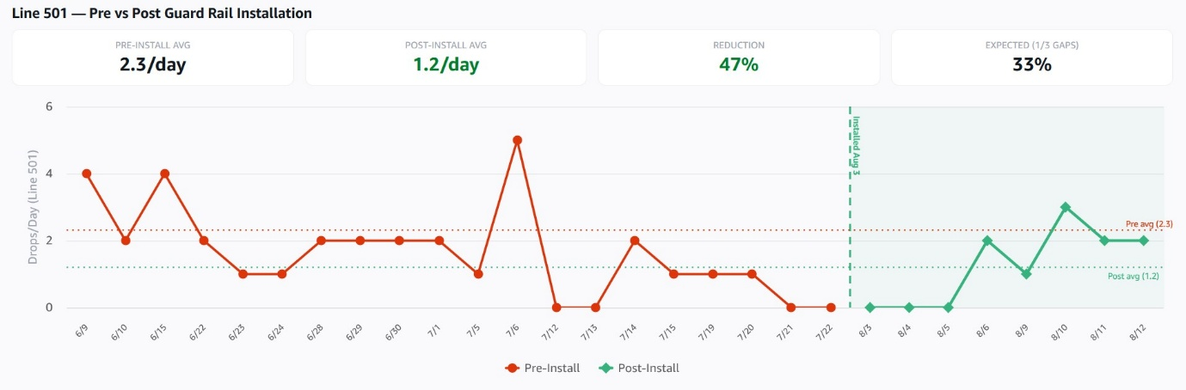
Figure 11.1: Pre vs Post Data

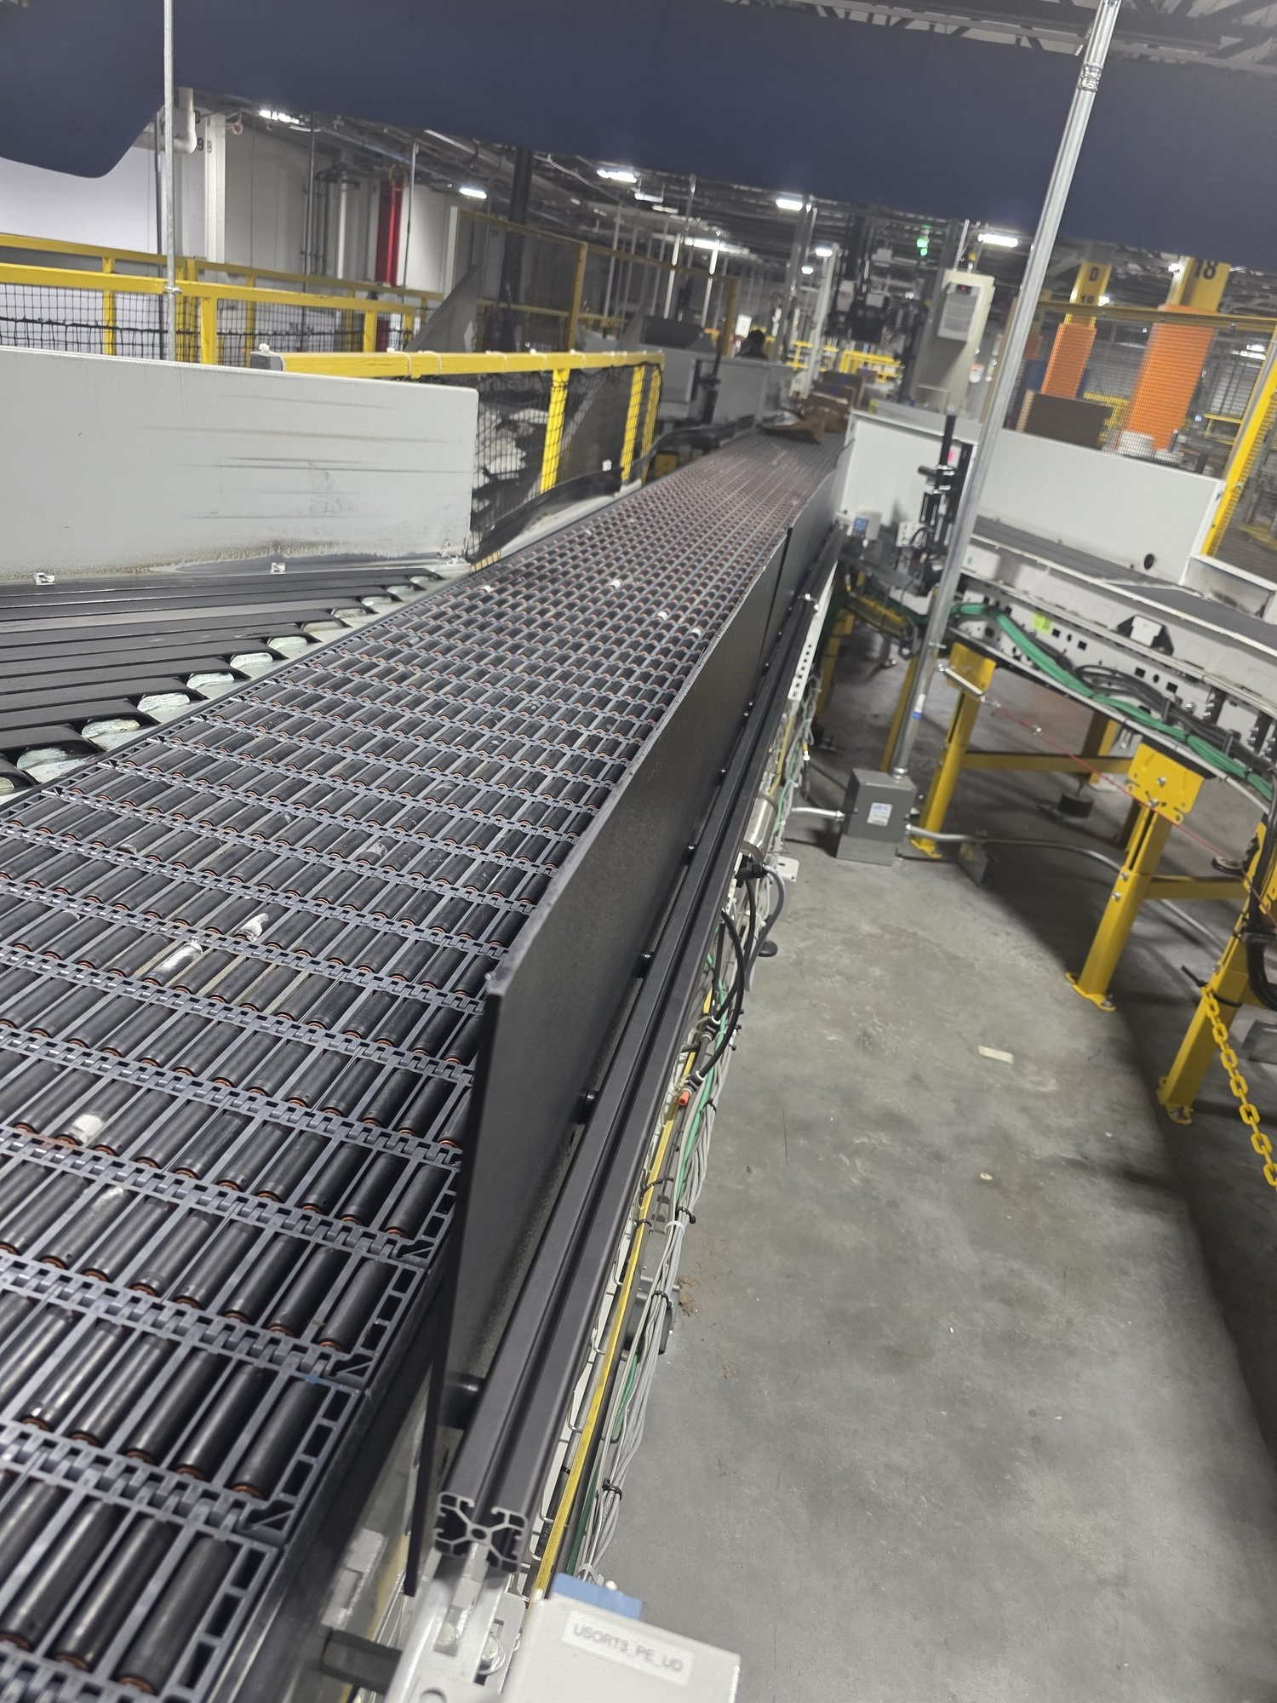
Figure 11.2: Completed guard rail assembly — side view along conveyor
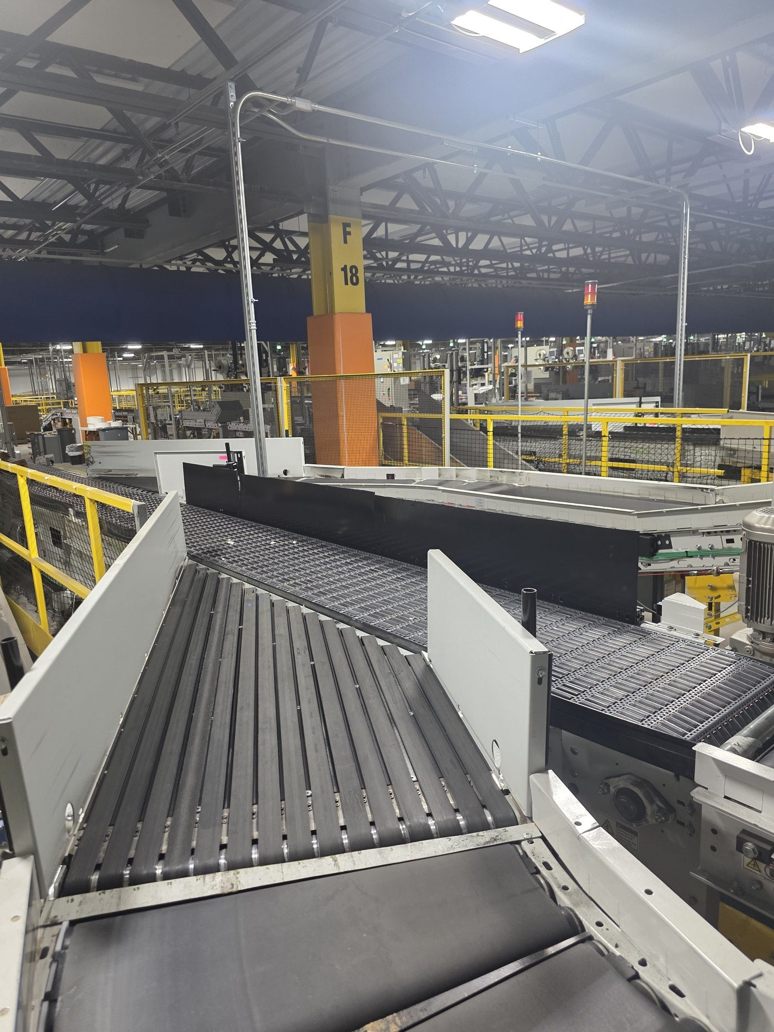
Figure 11.3: Guard rail as viewed from opposite side of conveyor
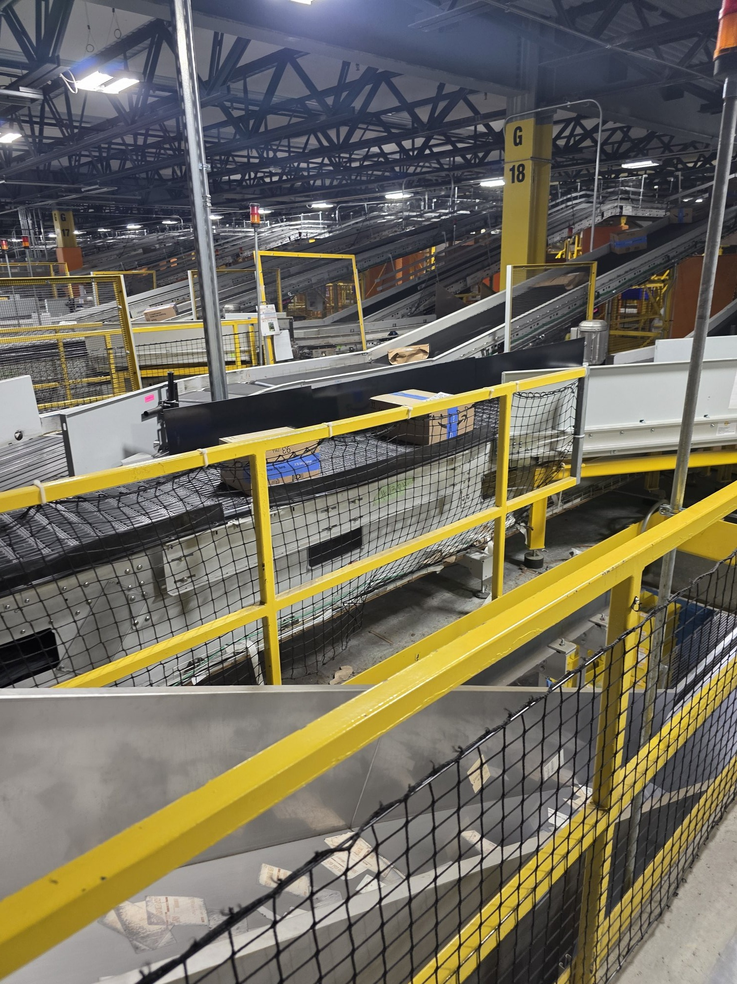
Figure 11.4: Guard rail during live operation with packages on belt

XIII. Cost Justification and ROI
The annual cost of package drops is estimated at approximately $22,000/year based on observed drop rates (~12 packages per shift, scaled to both shifts, 355 operating days, at $2.50 per DEA miss). Full methodology is detailed in Appendix A.

13.1 DEA Miss Cost Basis
According to Jock Simon (DEA Manager, TPA4-SFC), each dropped package constitutes a DEA miss valued at approximately $2.50. A dropped package misses its Critical Pull Time (CPT), resulting in delayed delivery and a customer promise miss. Associates cannot access packages beneath the SLAM conveyor structure; RME technicians must be dispatched to retrieve fallen packages.
The $2.50 figure represents only the direct DEA miss cost and does not include RME retrieval labor (~$2.08/incident at 5 minutes × $25/hr), potential customer concessions ($5–15 per missed promise), or throughput losses from belt stoppages. The true per-package cost is likely $4.50–$7.00+, making all estimates presented here conservative.

13.2 Material and Installation Cost
Total material cost for one guard rail assembly (125-inch total length): approximately $198. Components include VEVOR 4040 aluminum extrusion (2000 mm, 4-pack; two sections used: 78" + 47"), 4040 linear connector, ABS thermoplastic sheet panels (48×12×1/4 in., qty 3), M8 spring ball T-nuts, M8×35 mm button head screws , and 3D-printed aligner bracket and spacers (produced in-house at negligable material cost).
Installation labor is minimal. The guard rail bolts directly to existing L-brackets using the slotted mounting interface with no permanent modifications to the conveyor system. Estimated assembly and installation time is 1 hour for a single technician. Fully reversible for maintenance access.

13.3 Return on Investment
Scope | Value
THIS INSTALL (1 of 3 gaps, Line 501)
Cost | $198
Annual savings (47% of Line 501 drops) | ~$1,917/yr
Payback | ~38 days
FULL LINE 501 (all 3 gaps)
Cost | ~$594
Annual savings | ~$4,078/yr
Payback | ~53 days
FACILITY-WIDE ROLLOUT (9 lines × 3 gaps)
Cost | ~$5,346
Annual savings | ~$22,000/yr
Payback | ~89 days
At a total material cost of $198, this single installation addresses one of several gap locations. A full facility rollout across all SLAM lines represents a low-cost investment against approximately $22,000/year in DEA miss costs.

All estimates derived from statistical analysis of observational data. Only one of two daily shifts (Front Half Night, Sun-Wed) actively reports package drops. Volume data from AFT AutoSLAM4x FC Dashboard. Drop observations from #tpa4-dea-risk Slack channel. Cost per DEA miss from Jock Simon (DEA Manager).

XIV. Conclusion
This investigation identified and evaluated eight potential guard rail concepts for the 125-inch section on the SLAM line conveyor at TPA4-SFC. Through engineering analysis, deflection calculations, and structured decision-making, the ABS Thermoplastic on 4040 Aluminum Extrusion concept was selected for fabrication and installation.
The selected design provides a factor of safety of 3.7 under worst-case measured loading (297 N / 67 lbf), passes the L/240 deflection criterion without mid-span support, and utilizes the existing bracket mounting infrastructure without permanent modification. The estimated material cost of approximately $198 represents a cost-effective solution that can be implemented using Amazon procurement channels.
The guard rail system was successfully designed and installed, demonstrating the viability of the direct-mount 4040 extrusion approach for SLAM lines at TPA4-SFC. The design is easily scalable to additional conveyor locations with the configuration tool.

XV. Sources
[1] VEVOR. "4040 Aluminum Extrusion, 6063-T5, 2000mm, M8 T-Slot, Anodized Black, 4-Pack." Amazon.com.
[2] Polymersan. "ABS Sheet, 48 x 12 x 1/4 in, Vacuum Forming Grade, Textured One Side." Amazon.com.
[3] ASM International. "Aluminum 6063-T5 Material Properties." MatWeb Material Property Data. (E = 68.9 GPa, σ_{yield} = 145 MPa)
[4] Budynas, R. G., & Nisbett, J. K. Shigley's Mechanical Engineering Design, 11th Edition. McGraw-Hill. (Simply-supported beam deflection: δ = PL³/48EI)
[5] AISC. "Deflection Limits for Structural Members." L/240 serviceability criterion for non-critical structural elements.
[6] ISO 4017 / DIN 933. M8 Bolt Specifications — Thread pitch 1.25 mm, nominal diameter 8.0 mm.
[7] 3D Printer material datasheet for ASA/ABS bracket material. [If applicable]

XVI. Appendices

Appendix A: Estimation Methodology

Primary Estimate: Volume-Based Drop Rate Method
To produce the most direct estimate of annual package loss, the observed drop rate was calibrated against actual package throughput from the AFT AutoSLAM4x FC Dashboard.
Data Sources:
Package volume: TPA4 Attempts By Line, 30-day average (June 16 – July 15, 2026) from the AFT AutoSLAM4x FC Dashboard. This window avoids distortion from the July 4 facility closure.
Package drops: Slack #tpa4-dea-risk reports from July 5–14, 2026 (8 reporting days), filtered to only the six SLAM lines with matching volume data.

Annual cost: 8,804 × $2.50 per DEA miss = ~$22,000/year
Annual (×355 operating days): 24.8 × 355 = 8,804 packages/year
Average per day (×2 shifts): 12.4 × 2 = 24.8 packages/day
Average per shift: 1,017 ÷ 82 = 12.4 packages/shift
Total drops recorded: 1,017 packages (all 9 SLAM lines combined)
Total reports: 82 shift reports across the observation period

Appendix B: Bill of Materials
Item | Description | Qty | Source
ABS Panel | 48x12x1/4", vacuum forming grade | 3 | Amazon/Coupa
4040 Aluminum Extrusion | VEVOR 6063-T5, 2000mm + 1175mm cut | 2 | Amazon/Coupa
180mm Linear Connector | Straight connector, bottom + back | 2 | Amazon/Coupa
M6 Set Screw | Included with connector, 4 per | 8 | w/ connector
M8x25mm BHCS | Button head, 304 SS, panel bolts | 16 | Amazon/Coupa
M8 Spring Ball T-nut | 40-series drop-in, 4040 slot | 20 | Amazon/Coupa
M8 Washer | Bracket mounting, 1 per side | 2 | Amazon/Coupa
3D Printed Spacer | 6.1mm thick, 9mm ID (M8 clearance) | 16 | In-house
The following table lists the components used for the 125-inch SLAM Line 501 guard rail installation. Component quantities and specifications will vary for other conveyor sections depending on total coverage length, bracket spacing, and mounting configuration. Use the Configuration Tool to generate an accurate BOM for any specific installation.

Appendix C: Panel Aligner Bracket — Engineering Drawing

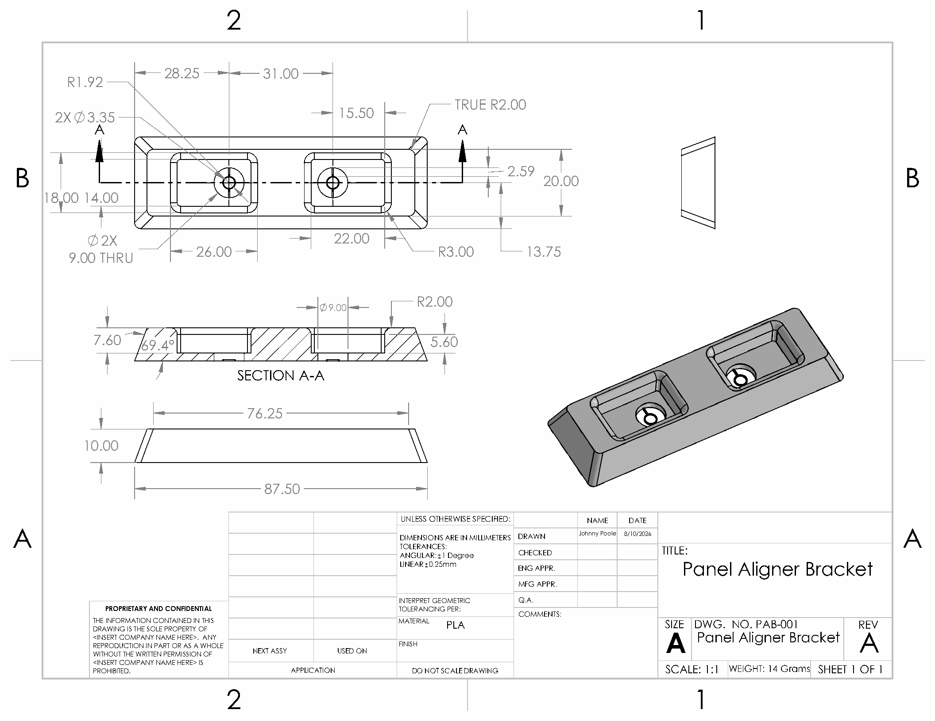
Panel Aligner Bracket — Engineering Drawing (dimensions in mm)

